|  |  |
| --- | --- |
| **1.** | **Explain in detail different component of Hard Disk Drive. (May-2011,Nov-**  **2014,May-2015)** |
|  | * The magnetic storage hard disk is based on a more than 40 year old technology and still is being improved rapidly. * Hard disks continue to shrink in size, gain increased storage capacity and increased transfer speeds. * IBM introduced the first hard disk in 1957, when data was usually stored on tapes.        * This includes hard disk physical construction, read/write head construction, its data density, RPM (Rotation per Minute) etc. |

## Components of Hard Disk Drive

* The basic components of a typical hard disk drive are as follows
  + Disk platters
  + Read/write heads
  + Head actuator mechanism
  + Spindle motor (inside platter hub)
  + Logic board (controller or Printed Circuit Board)
  + Cables and connectors
  + 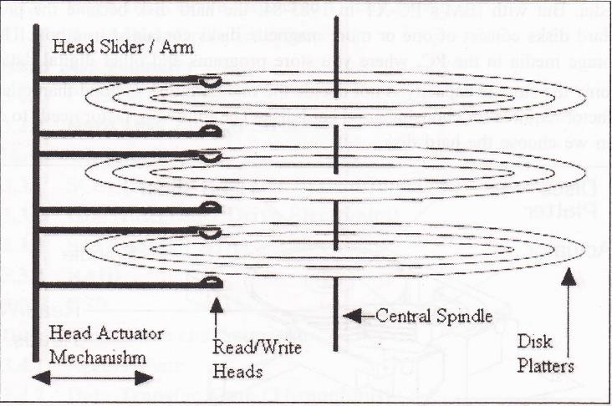Configuration items

## Disk Platters :

* All hard disks consist of thin platters with a magnetic coating.
* They rotate quite fast inside a metal container.
* Data are written and read by read/write heads, which are designed to ride on a microscopic cushion of air, without touching the platter. They register bits from the magnetic coating.
* A hard disk with three platters is shown in figure.
* Generally the hard disk has minimum 1 platter and maximum up to 10 (even more possible) depend on the hard disk manufacturer.

## Spindle Motor :

* The disk platters are connected to one central spindle, which is directly connected to the main spindle motor.
* Most of the Hard disk drive spindle motor is located at the bottom of the drive.
* Spindle motor gives circular rotation to the platters for Read/Write operation on specific location.
* On some drives the spindle is connected to the spindle rotation motor through some belt or gears. This motor works on a feedback loop to automatically adjust the disk's rotation speed.
* To use more platters in Hard disk drive the spindle, motor is directly built into the platter hub inside the sealed assembly. This will allow adding more platters in hard disk drive because the spindle motor does not take any additional vertical space.

## Read/Write Head

* As shown in above with 3 platters, it has 6 read/write heads, two heads for every one platter, which move synchronously the arms which guide the movement of the read/write heads move in and out.
* These heads do not require cleaning or any other maintenance, as the floppy drive heads because these heads do not touch the disk surface instead it floats a distance above the disk surface during the read/write process. When specifying the head number for reading or writing any information onto the disk drive. The first head is specified as head 0 next 1 so on.
* The synchronous movement of these arms is performed by an electro-mechanical system called the head actuator.
* When the disk rotates under the read/write head it can either read existing data or write new ones.
* In write mode, current is applied to the coil the head will become magnetic.
* This magnetism will orient the micro magnets in the track.
* If the head moves along the track without current applied to the coil, it will sense the micro magnets in the track.
* 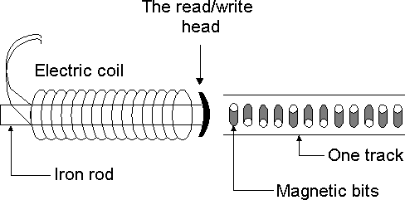This magnetism will induce a current in the coil. These flashes of current represent the data on the disk. This is read mode.

## Head Actuator Mechanism:

* To moving read/write head of the Hard disk drive on the disk platters is referred as Head Actuator Mechanism.
* There are two type of Head Actuator Mechanism
  1. **Stepper Motor Actuator (Open-loop disk drive)-** A stepper motor rotates in fix angle with each step. Earlier low capacity, low cost Hard disk drive used this type of Actuator assembly to move read/write head.
  2. **Voice Coil Actuator (Closed-loop disk drive)-** The actuator in a modern hard disk uses a device called a voice coil to move the head arms in and out over the surface of the platters, and a closed-loop feedback system called a servo system to dynamically position the heads directly over the data tracks. The voice coil works using electromagnetic attraction and repulsion.

|  |  |
| --- | --- |
| **2.** | **Explain in detail logical structure of Hard disk.(Nov-2014,May-2015)** |
|  | Following are the major logical part of the Disk:   * Sides or Heads * Tracks * Cylinder * Sector * Zone  1. **Sides or Heads-** Drive with three platters one can read and write on six sides. If the drive is servo based then one side may be used for the servo information and only 5 usable sides will be available. This type of drive used in early system. Each side of the disk has a separate read/write head to read/write on the disk surface.      1. **Tracks -** Each side of the hard disk drives platter’s surface is divided into concentric circles called tracks as shown in above fig. Each track is identified by its number.    * The outer most tracks are given track number 0 the next one 1 and so on. The inner most track have the highest track number. The numbers of tracks are depending on the hard disk manufacturer. Generally there are 300 to 500 in range. Typically disk with more tracks may give more hard disk data storage capacity. 2. **Cylinder –** The hard disk having more than one platter makes virtually a cylinder like structure on same tracks of different platters as shown in figure.      * + For example the track i on the all the platter is make a cylinder i. The data is stored cylinder by cylinder on the disk. First all the tracks of same cylinder are written. Once a cylinder becomes full the read/write head moves to the next cylinder for writing remaining data. |

## These logically divide the disk in cylinder gives following advantages:

1. When the read/write head is moved to a specific cylinder all the heads are on the same track, so that it is faster to write on this particular track on all the sides.

For example disk having six heads, when the head 0 is moved to track 4, all the other heads also move to track number 4 on their respective sides. Writing on this particular track on all the 6 sides is faster, compared to moving the head to next track and continue writing on each of sides.

1. This method of writing on the complete cylinder before moving the head to next cylinder reduces the read/write head movement, which improve speeds of read/write data operation on disk. Because the maximum time is wasted in read/write head movement while writing the data on disk.

## Sector -

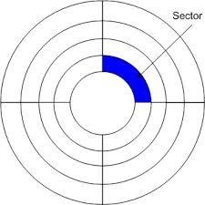

* + The tracks are dividing further which is called the sector. During the formatting of the hard disk, the formatting program divides the disk surface into different sector by writing magnetic pattern on the disk surface. Different capacity of hard disk drive divides the track into different number of sectors 17 to 100 or more sectors per track are very common.
  + As a standard on almost all the drives are stored 512 bytes on each sector.
  + The sector always starts with the number one while the track and cylinder are start with zero.

## Interleave:

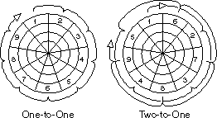

* System hardware and software may not be fast enough to read or write a series of sectors consecutively. This is especially in the case of earlier disk drives.
* For example, after writing 1 sector the data for the next sector may not be in the buffer yet, and so cannot be written into the adjacent sector. The disk in this case would interleave the sectors so that sufficient time is given for the data to be ready by skipping the next one or two sectors as shown in fig.

|  |  |
| --- | --- |
|  | 1. **Zone –**    * When we logically divide the disk in tracks and sector, due to circular shape the outer track or the outer cylinder has much more area compared to the inner track of the disk drive.    * Allocating same number of sectors in the outer as well as inner track of the drive is a waste of the storage capacity of the disk drive. The outer tracks have larger area compare to inner tracks, it can be easily divide more sector compare to inner one. if we do that the storage capacity of the disk is become larger.    * A new recording system called Zone bit Recording is used by the currently high capacity IDE and SCSI hard disk drives to store more number of sectors in the outer tracks compared to the number of sectors in the inner tracks. Each zone will have a fixed number of sectors per tracks.    * The outermost zone will have maximum number of sectors per track and the inner most zone will have minimum number of sectors per track. 2. **Zone Bit Recording-**    * Zone Bit Recording (ZBR) is used by disk drives to store more sectors per track on outer tracks than on inner tracks. It is also called Zone Constant Angular Velocity**.** 3. **MBR-**    * A master boot record (MBR) is a special type of boot sector.    * The MBR holds the information on how the logical partitions, containing file systems, are organized on that medium. 4. **Cluster-**    * Each partition on your hard disk is subdivided into clusters. A cluster is the smallest possible unit of storage on a hard disk.    * The size of a cluster depends on two things:      1. The size of the partition      2. The file system installed on the partition |
| **3.** | **Explain different types of Hard Disk Drive.**  **OR**  **Explain different types of Hard Disk Drive Interfaces. (Dec-2011, May-2012, May- 2013, May-2014,Nov-2014,May-2015)** |
|  | 1. **SCSI (Small Computer System Interface)**    * SCSI pronounced as "scuzzy", is a system level interface instead of a device level interface. A device level interface is designed for particular device and the signals used in that interface will not work with other devices.    * For example the ATA type interface work only for that type of device but not work for printer or other peripherals.    * A system level interface on the other hand is not based on any specific device instead it uses signals that are converted from device level signals to the signals used by the host computer system.    * A SCSI connection is support number of devices on an expansion bus. A SCSI bus can support up to 8 different devices. New devices can be added to the system in daisy chain.    * Each new device is connected at the end of the old devices as shown in figure. |

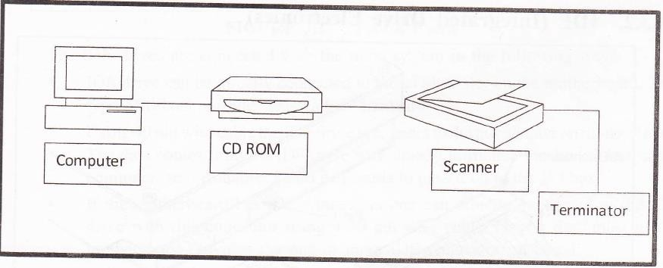

* The SCSI adapter card used for connecting SCSI device to the system.
* I/O port is treated as one of the device this leaves space to connect seven more devices in a single SCSI host adapter. These devices can be SCSI compatible CD ROM drive, printer etc.
* A SCSI compatible drive is basically an ATA IDE hard disk drive with SCSI adapter embedded in its circuit. This is the reason these drives are also known as **“Embedded SCSI”** drives.

## IDE (Integrated Drive Electronics)

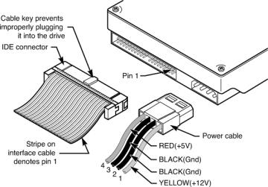

* + One of the biggest problems with the 5T-506/4i2 interface was its controller was away from the drive.
  + As the distance between the controller and the drive increased, there may be chance of data lost. They integrated the controller in drive itself .which called the IDE. These types of drives are also known **Parallel Advanced Technology Attachment (PATA).**
  + This led to removing the need for long cables to connect the controller with drive. IDE make the system more reliable, low cost and also allow putting 30 or more sectors per track on these drives.

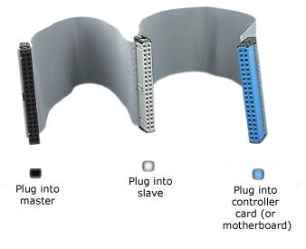

Fig. PATA CABLE

* + The IDE drives are connected with the main system in the following ways:

1. IDE drive can be directly connected to the I/O bus slot on the motherboard. This type of drive/controller was called **“Hardcard”**.
2. Using 40 pin wire cable the IDE drive is connect to the bus adapter on motherboard. The data comes from the IDE drive was already formatted for the I/O bus of the computer, so the adapter board just needs to pass it on to the IO bus.
3. If the motherboard has IDE connectors one can directly connected to the IDE drive with this connector using a 40 pin wire cable. Now a day, most of the motherboard provides the one or more IDE connector on board.
   * Based on type of the system bus. there are four type of IDE:
4. ATA IDE (AT Attachment IDE)
5. XTA IDE
6. MCA IDE
7. EIDE

## EIDE

* + Enhanced or Extended IDE was introduced by the western Digit (WD).
  + This interface allows the BIOS to supports up to 8 GB large hard disk drives.
  + This interface sometimes refers as ATA-2 interface. EIDE supports very high speed for data transfer.
  + It can use in programmed I/O mode or in DMA mode to get data transfer up to 13.3 MB per second.
  + EIDE interface can allow connecting other devices like tape-drive CD ROM etc. EIDE has high speed interface for high capacity hard disk drives.

## SATA (Serial ATA)

* + A serial version of the ATA (IDE) interface, which has been the de facto standard hard disk interface for desktop PCs for more than two decades.
  + SATA was introduced in 2002 at significantly higher speed, transferring data in each direction at 1.5 Gbps. A year later, SATA II increased speed to 3 Gbps.
  + SATA provides a point-to-point channel between motherboard and drive rather than the master-slave architecture in the parallel technology.
  + SATA uses a four-wire shielded cable up to one meter in length compared to the wide flat 18" PATA (Parallel ATA) cables. SATA cables as shown in following figure connectors are considerably smaller than their PATA and take up a lot less space in the case.

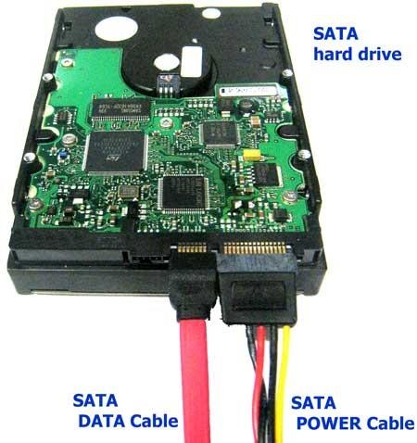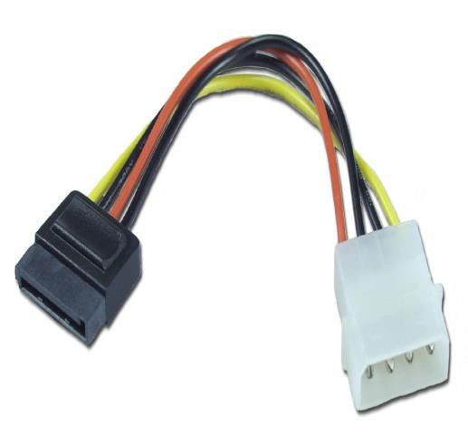

|  |  |
| --- | --- |
|  | 1. **RAID**    * Redundant Array of Independent Drives (or Disks) also known as Redundant Array of Inexpensive Drives (or Disks).    * RAID offers different schemes for increased data reliability and/or I/O performance.    * Most schemes are numbered and referred to as levels. RAID began as a collection of such five levels.   **RAID Basic Functions**   * + Fundamentally, RAID combines multiple hard disks into a single logical unit. There are two ways this can be done: in hardware and in software.   + Hardware combines the drives into a logical unit in dedicated hardware which then presents the drives as a single drive to the operating system.   + Software does this within the operating system and presents the drives as a single drive to the users of the system.   **RAID levels-**   1. **RAID 0: Striped Set (2 disks minimum) without parity.** 2. **RAID 1: Mirrored Set (2 disks minimum) without parity.** 3. **RAID 3 and RAID 4: Striped Set (3 disk minimum) with Dedicated parity** 4. **RAID 5: Striped Set (3 disk minimum) with Distributed Parity.** 5. **RAID 6: Striped Set (4 disk minimum) with Dual Distributed Parity.** 6. **USB**    * Now a day USB hard drives are more popular.    * Advantage of External hard drives is that the computers and laptops have a chance of losing data all the time and also theft is very common as far as laptop is concerned.    * External hard drives are ideal for backing up your hard drive or storing from your main hard drive.    * Now a day l TB hard disks are also very common as the backup’s drives. |
| **4.** | **Explain various Disk performance characteristics** |
|  | 1. **Access Time**    * The access time or response time of a rotating drive is a measure of the time it takes before the drive can actually transfer data.    * The factors that control this time on a rotating drive are mostly related to the mechanical nature of the rotating disks and moving heads.    * The key components that are typically added together to obtain the access time are: seek time and rotational latency.   **Seek Time**   * + The seek time measures the time it takes the head assembly on the actuator arm to travel to the track of the disk where the data will be read or written.   + It uses the actuator to move the head to that particular track. If the initial location of the head was the desired track then seek time would be zero. If the initial track was the outermost edge of the media and the desired track was at the innermost edge then seek time would be the maximum for that drive.   + In practice it is determined by statistical methods as the time of a seek over one-third of the number of tracks. desktop drives typically being around 9 ms.   + The other two less commonly referenced seek measurements are track-to-track and full stroke. |

|  |  |
| --- | --- |
|  | * The track-to-track measurement is the time required to move from one track to an adjacent track. This is the shortest (fastest) possible seek time. In HDDs this is typically between 0.2 and 0.8 ms. * The full stroke measurement is the time required to move from the outermost track to the innermost track. This is the longest (slowest) possible seek time.   **Rotational Latency**   * Rotational latency also called rotational delay or just latency. * It is the delay waiting for the rotation of the disk to bring the required disk sector under the read-write head. * lt depends on the rotational speed of a disk (or spindle motor), measured in revolutions per minute (RPM). * Hard drive's disk platters are continuously spinning. When the I/O request arrives it is highly unlikely that the platter will be at exactly the right point in its rotation necessary to access the desired sector. Therefore, even if the rest of the drive is ready to access that sector, it is necessary for everything to wait while the platter rotates. Bringing the desired sector into position under the read/write head.  1. **Data transfer Rate(Throughput)**    * The data transfer rate of a drive also called throughput covers both the internal rate- moving data between the disk surface and the controller on the drive and the external rate- moving data between the controller on the drive and the host system.    * The internal rate is further determined by the media rate, sector overhead time, head switch time, and cylinder switch time.   **Media rate**   * + Rate at which the drive can read bits from the surface of the media.   **Sector overhead time**   * + Additional time (bytes between sectors) needed for control structures and other information necessary to manage the drive locate and validate data and perform other support functions.   **Head switch time**   * + Additional time required to electrically switch from one head to another and begin reading: only applies to multi head drive and is about 1 to 2 ms.   **Cylinder switch time**   * + Additional time required to move to the first track of the next cylinder and begin reading.   + This time is typically about twice the track-to-track seek time. |
| **5.** | **Explain in brief Hard Disk Controller(HDC)(May-2015)** |
|  | * A hard disk controller (HDC) is an electrical component within a computer hard disk that enables the processor or CPU to access, read write, delete and modify data to and from the hard disk. * Early disk controllers were identified by their storage methods and data encoding, they were typically implemented on a separate controller card * The most common types of interfaces provided nowadays by disk controllers are PATA (IDE) and Serial ATA for home use. High-end disks use SCSI, Fiber Channel or Serial Attached SCSI. Disk controllers can also control the timing of access to flash memory which is not mechanical in nature.   **HDC Function**   * A hard disk controller's primary function is to translate the instructions received from the computer into something that can be understood by the hard disk and vice versa. |

|  |  |
| --- | --- |
|  | * It consists of an expansion board and its related circuitry, which is usually attached directly to the backside of the hard disk. * The instructions from a computer flow through the hard disk adapter into the hard disk interface and then onto the HDC, which sends commands to the hard disk for performing that particular operation. * Typically, the type and functions of a hard disk controller depend on the type of interface being used by the computer to access the hard disk. For example. an IDE hard disk controller is used for IDE interface based hard disks. |
| **6.** | **Explain in detail Hard Disk Drive Installation process (Oct-2012, May-2013, May- 2014)** |
|  | * An Enhanced Ultra ATA IDE (integrated Drive Electronics) hard disk drive cable. This supports up to two IDE hard disk drives, one of which is already connected, this cable is labeled "HDD". * For optimum performance use this cable to connect IDE hard disk drives that are Ultra ATA compatible. * A second Enhanced IDE drive cable that supports up to two IDE devices. if you install a CD- ROM Drive or a Zip Drive, connect to this cable. This cable is labeled “CD-ROM”. * First, we need to ensure that the hard drive is set up to be the master drive on its IDE cable. * Each IDE cable can supports up to two IDE devices such as hard-drives, CD-drives, Zip drives etc. but in order for this to work , one IDE device must be designated as a master device, and one must be designated as a slave device. * You cannot have two master device or two slave devices on a single cable. So for that you have to do necessary jumper setting to make the drive a master or slave devices. * Insert the hard drive into the 3.5” drive-tray and screw it in securely on both sides. * Attach molex power cable to the drive.      * Then Attach the Primary IDE cable to the drive. |
| **7.** | **Explain in brief DVD (Digital video Disk).also explain different types of DVD.(Nov-**  **2014)** |
|  | * The DVD (Digital Video Disc or Digital versatile Disc) is similar to a CD, but uses laser light with a shorter wavelength * A DVD disk typically stores up to 4.7 GB of data, equivalent to about six CDs. This capacity can be doubled by using both sides of the disk. * The high capacity of DVD-ROMs (and their recordable equivalent DVD-RAMs) makes them useful for storing feature-length movies or videos. Very large games and multimedia programs or large illustrated encyclopedias. |

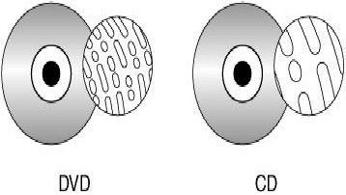

|  |  |
| --- | --- |
|  | **Types of DVD**   * **DVD-R** is a digital optical disc storage format. A DVD-R is a DVD that can be written once and read arbitrarily many times. A DVD-R typically has a storage capacity of 4.7 GB. * **DVD+R** is a digital optical disc storage format. A DVD+R is a DVD that can be written once and read arbitrarily many times. A DVD-R typically has a storage capacity of 4.7 GB. * The difference between DVD-R & DVD+R is follow. * DVD-R discs use tiny marks along the grooves in the discs, called land prepits, to determine the laser position. DVD+R discs do not have land prepits, but instead measure the "wobble frequency" as the laser moves toward the outside of the disc. * **DVD-R DL** (DL stands for **Dual Layer**), also called **DVD-R9**, is a derivative of the DVD-R format standard. DVD-R DL discs hold 8.5 GB by utilizing two recordable dye layers, each capable of storing a little less than the 4.7 gigabyte (GB) of a single layer disc, almost doubling the total disc capacity. * **DVD+R** DL (DL stands for Double Layer) also called DVD+R9, is a derivative of the **DVD+R**   format   * A **DVD-RW** disc is a rewritable optical disc with equal storage capacity to a **DVD-R**, typically 4.7 GB (4,812,800,000 bytes). * The primary advantage of DVD-RW over DVD-R is the ability to erase and rewrite to a DVD- RW disc. * **DVD+RW** is a physical format for rewritable DVDs and can hold up to 4.7 GB. |
| **8.** | **Explain in detail DVD Physical Format/Construction in detail.(Nov-2014)** |
|  | * Based on data capacity DVD have following three physical format:   1. Smaller pit size   2. Tighter track spacing   3. Multi layer capability   **Smaller Pit Size**   * DVDs have smaller pit size than CDs**.** * Pits are the slight depressions or dimples on the surface of the disc that allow, the laser pickup to distinguish between the digital 1's and 0's.   **Tighter Track Spacing**   * DVDs also feature tighter track spacing (i.e., track pitch) between the spirals of pits. * In order for a DVD player to read the smaller pit size and tighter track spacing of the DVD format, a different type of laser with a smaller beam of light is required. * This is one of the major reasons why CD players cannot read DVDs, while DVD players are capable of reading Audio CDs. |

## Multiple Layer Capability

* DVDs may have up to 4 layers of information, with two layers on each side. To read information on the second layer" on the same side, the laser focuses deeper into the DVD and reads the pits on the second layer.
* When the laser switches from one layer to another layer, it is referred to as the "layer switch" or the "RSDL (reverse spiral dual layer) switch".
* To read information from the other side of the DVD almost all DVD players require the user to manually flip the disc.

## DVD Application Formats

1. **DVD Video**
2. **DVD Audio**
3. **DVD ROM**

* Based on DVD’s dual-layer and double-sided options, there are four disc construction formats:

## Single-sided, single-layered

1. **Single-sided, dual-layered**
2. **Double-sided, single-layered**
3. **Double-sided, dual-layered**
4. **Explain in detail DVD drive interface**
   * Most internal drives for personal computers, servers and workstations are designed to fit in a standard 5.25" drive and connect to their host via an ATA or SATA interface.
   * Additionally, there may be digital and analog outputs for audio.
   * The outputs may be connected via a header cable to the sound card or the motherboard.
   * External drives usually have USB or Fire wire interfaces.
   * Some portable versions for laptops power themselves from batteries or directly from their interface bus.
   * Drives with SCSI interface were made, but they are less common and tend to be more expensive, because of the cost of their interface chipsets more complex SCSI connectors and small volume of sales.

# Explain CAV versus CLV.

|  |  |
| --- | --- |
| **CAV** | **CLV** |
| Constant angular velocity. | Constant linear velocity. |
| Used in HDDs. standard FDDs | Used mainly in optical storage |
| Spins the media at one constant speed. | Spins the media at varying speed. |
| When the bit density is not constant long outside tracks have the same number of bits as the shorter inside tracks and is generally combined with CAV spin rate. | When the bit density is constant, outside tracks have more bits than inside tracks and is generally combined with a CLV spin rate. |

1. **Write Blu-ray disk specification(Nov-2014,May-2015) OR Write the difference between Blu-ray & DVD.**

|  |  |  |
| --- | --- | --- |
| **Parameter** | **Blu-Ray** | **DVD** |
| Storage Capacity | 25GB(Single –layer)  50GB(dual-layer) | 4.7G8 (single-layer)  8.5G8 (dual-layer) |
| Laser wavelength | 405nm (blue laser) | 650nm (red laser) |
| Numerical aperture (NA) | 0.85 | 0.60 |
| Disc diameter | 120mm | 120mm |
| Disc thickness | 1.2mm | 1.2mm |
| Protection layer | 0.1mm | 0.6mm |
| Hard coating | Yes | No |
| Track pitch | 0.32µm | 0.74µm |
| Data transfer rate(data) | 36.0Mbps(1X) | 11.08Mbps(1X) |
| Data transfer rate  (video/audio) | 54.0Mbps(1.5X) | 10.08Mbps(<1X) |
| Video resolution (max) | 1920x1080 (1080p) | 720x480/720x576 |
| Video bit rate (max) | 40.0Mbps | 9.8Mbps (480i//480p/576i) |
| Video codec | MPEG-2 MPEG-4 AVC  SMPTE VC- 1 | MPEG-2  ------  ------ |
| Audio codec | Linear PCM Dolby Digital Dolby Digital plus Dolby True-HD DTS Digital Surround  DTS-HD | Linear PCM Dolby Digital  DTS Digital Surround  ------  ------  ------  ------ |
| Interactivity | BD-J | DVD Video |